
Contents
Objective 3
Phase 1: 3
1. Clock Pulse Generator: 3
2. Program Counter 5
3. Input Unit 7
4. Address Box 8
5. Memory Address Register (MAR) 8
Phase 2: 13
1. Accumulator 13
2. B Register 16
3. Output Register 18
4. Random Access Memory 20
Phase 3: 27
1. Arithmetic and Logic Unit (ALU): 27
Phase 4: 30
Instruction Register 30
Controller Sequencer 32

Objective
The objective of the project is to implement an 8-bit computer based on the architecture of SAP-1 (Simple-As-Possible) using combinational sequential circuits.

Phase 1:

1. Clock Pulse Generator:
Block Diagram:
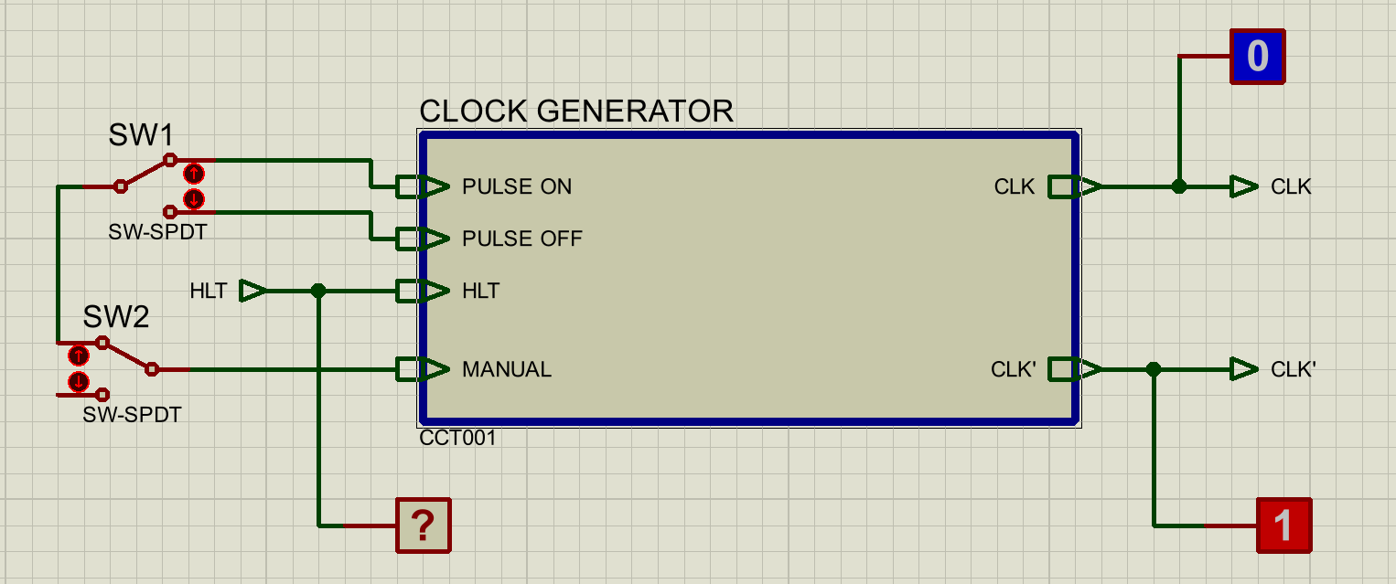
Figure 1 Block Diagram of Clock Pulse Generator
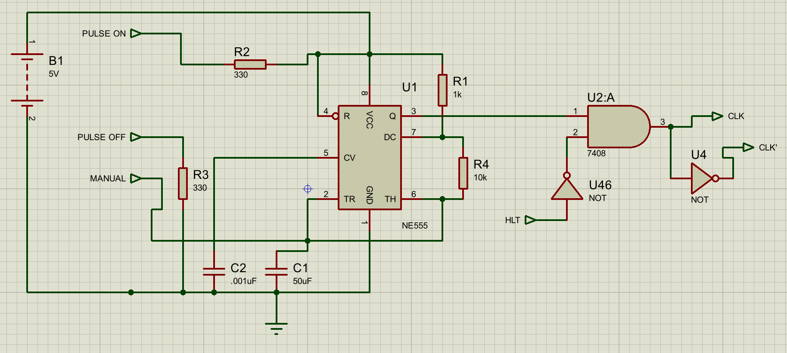
Figure 2 Circuit Diagram of Clock Pulse Generator

Input and Output Signals
Inputs
- PULSE ON: Enables clock pulse generation.
- PULSE OFF: Disables clock pulse generation.
- MANUAL: Selects manual clock operation.
- HLT: Halt control signal used to stop the clock output.
Outputs
- CLK: Main system clock signal.
- CLK′: Complementary clock signal.

Circuit Description
The clock pulse generator is implemented using an NE555 timer in combination with logic gating circuitry. The NE555 timer serves as the primary timing element and is configured to support both continuous and user-controlled pulse generation. Depending on the selected mode of operation, the timer exhibits behavior equivalent to astable and monostable multivibrators.
In automatic clock mode, the NE555 operates in a continuous pulse generation mode, producing a periodic clock signal that drives the system sequentially. This mode corresponds functionally to astable multivibrator operation, where clock pulses are generated continuously at a fixed frequency determined by the external resistor–capacitor network.
In manual clock mode, the same NE555 timing circuit produces discrete clock pulses under user control. Each manual trigger results in a single clock transition, allowing step-by-step execution of the system. This mode exhibits behavior equivalent to a monostable multivibrator, where a single pulse is generated in response to a control action.
Selection between automatic and manual clock operation is achieved through direct control signals and logic gating rather than a dedicated multiplexer. The design does not employ a separate 2×1 multiplexer for clock selection; instead, the operating mode is controlled by enabling or disabling pulse generation through the timer’s control inputs. This approach simplifies the circuit while preserving correct functional behavior.
The generated clock signal is routed through a halt control stage implemented using logic gates. The halt signal is inverted and combined with the clock waveform using an AND gate, ensuring that the clock output is enabled only when the halt signal is inactive. When the halt signal is asserted, the clock output is forced to a constant logic level, effectively stopping system operation without disabling the timing circuit itself.
Finally, the main clock output (CLK) is inverted using a logic inverter to produce a complementary clock signal (CLK′). Both clock phases are made available to the system to support synchronous operation of different modules.
Algorithm
- The clock generator reads the control inputs to determine the selected operating mode.
- If the pulse generation is disabled, the clock output remains inactive.
- If pulse generation is enabled, the clock generator operates in one of the following modes:
  - Automatic mode, in which continuous clock pulses are generated.
  - Manual mode, in which clock pulses are generated only through user control.
- The halt signal is monitored continuously. When the halt signal is asserted, the clock output is disabled.
- When the halt signal is deasserted, the clock output resumes normal operation.
- A complementary clock signal is generated by inverting the main clock output.
Truth Tables

PULSE ON | PULSE OFF | MANUAL | HLT | Clock Operation
0 | 1 | X | 0 | Clock Off
1 | 0 | 0 | 0 | Automatic Mode
1 | 0 | 1 | 0 | Manual Mode
X | X | X | 1 | Halted

2. Program Counter
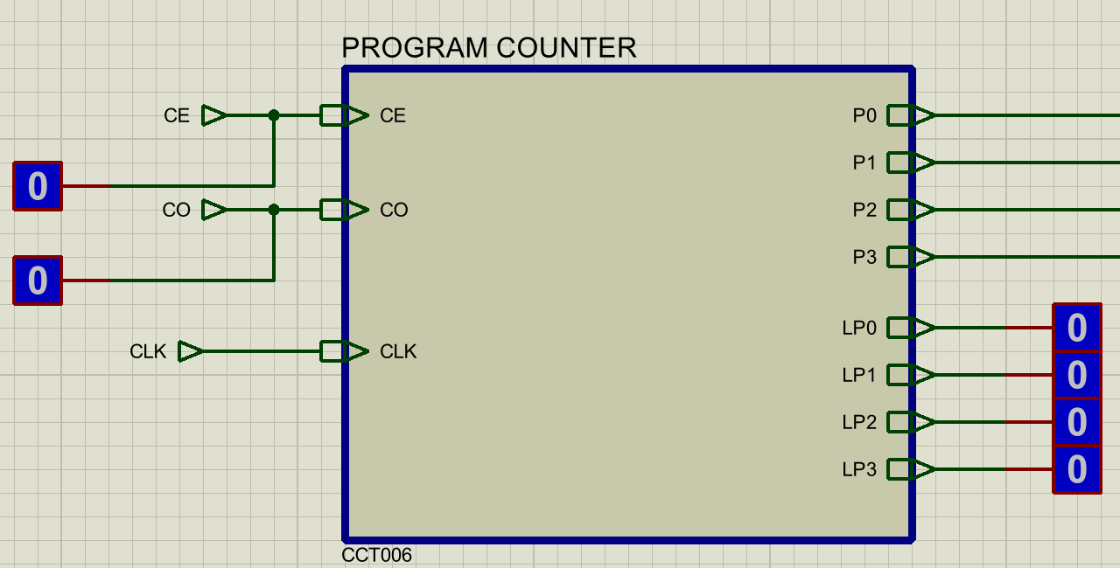
Figure 3 Block Diagram of Program Counter
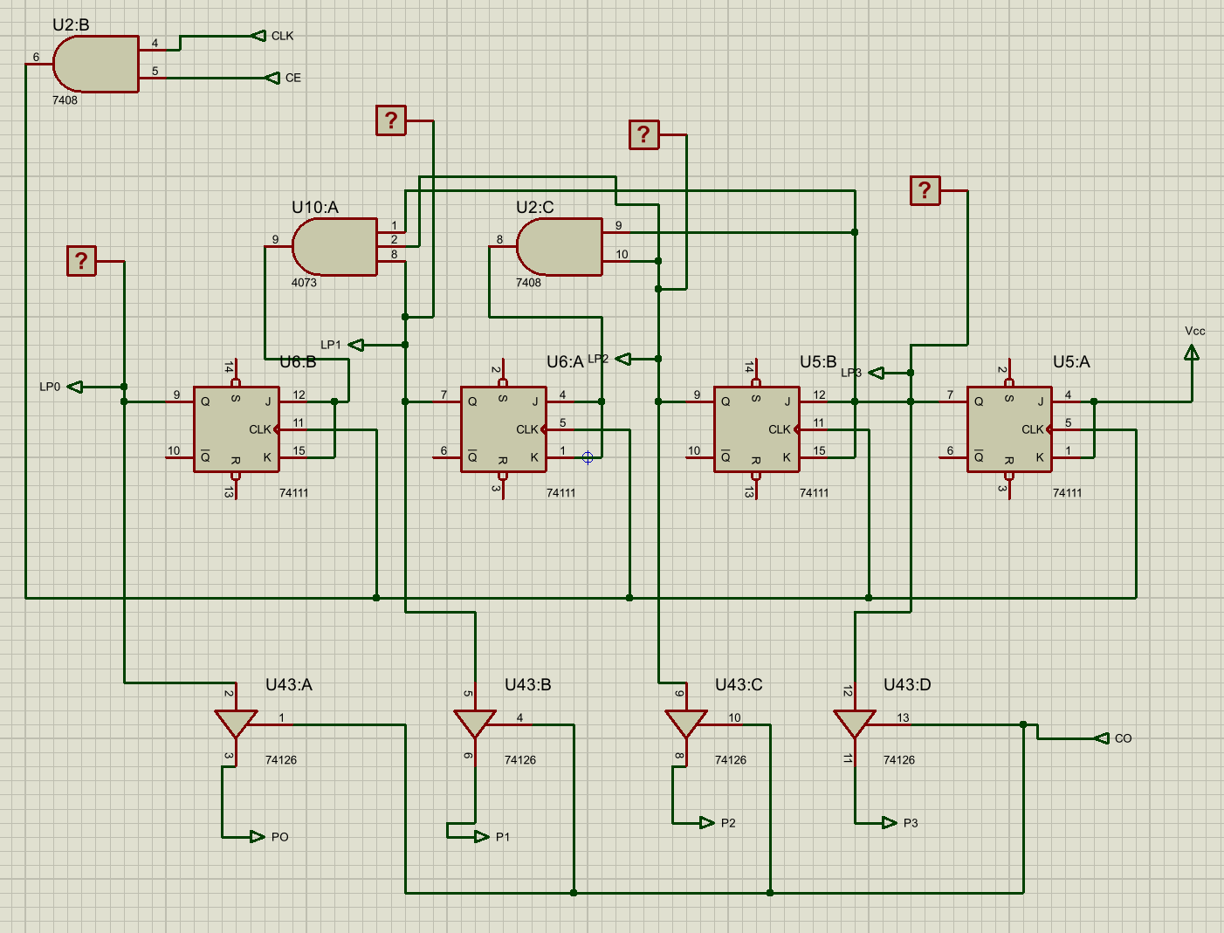
Figure 4 Circuit Diagram of Program counter
Input and Output Signals
Inputs
- CLK: Provides timing for the program counter operation.
- CE (Count Enable): Controls whether the program counter increments.
- CO (Counter Out): Enables the program counter value to be placed on the output lines.
Outputs
- P0, P1, P2, P3: Four-bit program counter output.
- LP0, LP1, LP2, LP3: Internal monitoring points used to observe the counter value during simulation.

Circuit Description
The program counter is implemented as a 4-bit binary counter using JK flip-flops. Each flip-flop stores one bit of the program counter value. Together, the four flip-flops represent the current instruction address.
The clock signal is controlled using logic gating so that the counter increments only when counting is enabled. When the CE signal is active, clock pulses are allowed to reach the flip-flops and the counter advances. When CE is inactive, the clock is blocked and the program counter holds its current value.
The counter is designed to increase its value by one on each enabled clock pulse. The least significant bit toggles first, and the higher-order bits change state only when required, producing standard binary counting behavior from 0000 to 1111.
To avoid conflicts on the address bus, the program counter outputs are connected through tri-state buffers. These buffers allow the counter value to appear on the output lines only when the CO signal is active. When CO is inactive, the outputs are disconnected from the bus.
This design ensures that the program counter increments correctly and shares the bus safely with other system components.

Algorithm
The program counter waits for a clock pulse.
If CE is inactive, the stored value remains unchanged.
If CE is active, the program counter increments by one on the clock edge.
The CO signal controls whether the current program counter value is sent to the output lines.
When CO is inactive, the outputs remain in a high-impedance state.

Truth Table
CE | Program Counter Operation
0 | Holds current value
1 | Increments by one

CO | Output State
0 | High-impedance
1 | Program counter value output

3. Input Unit
The input unit is implemented using manual switches. Two sets of switches are provided:
- Address switches (AD0–AD3) for selecting memory addresses
- Data switches (D0–D7) for entering data values
These switches are mainly used in program mode. During this mode, the user selects an address using the address switches and places the corresponding data value on the data switches. The entered address is routed through the address box, while the data value is written into memory.
The input unit is not active during normal execution. Once the program is loaded, control is transferred to the program counter for automatic address generation.

4. Address Box
Input and Output Signals
Inputs
- AD0–AD3: Address lines from the input unit
- QD0–QD3: Address lines from the program counter
- RUN/PROG: Mode selection signal
Outputs
- Y0–Y3: Selected address lines sent to the Memory Address Register
The address box is implemented using a 74LS157 2×1 multiplexer. One set of inputs to the multiplexer comes from the address switches, while the other set comes from the program counter outputs.
The RUN/PROG signal controls the multiplexer selection:
- When the system is in program mode, the address from the input unit is selected.
- When the system is in run mode, the address from the program counter is selected.
The selected address is forwarded directly to the Memory Address Register. This design ensures that the memory always receives the correct address source based on the current mode of operation.
Algorithm
The system checks the state of the RUN/PROG control signal.
If RUN/PROG indicates program mode, the address from the input unit is selected.
If RUN/PROG indicates run mode, the address from the program counter is selected.
The selected address is sent to the Memory Address Register.
Truth Table
RUN/PROG | Address Source Selected
0 | Program Counter
1 | Input Unit (Address Switches)

5. Memory Address Register (MAR)
Input and Output Signals
Inputs
- DM0–DM3: Address lines from the address box
- MI: Memory Input (load enable)
- CLK: System clock
Outputs
- QM0–QM3: Stored memory address outputs

The MAR is implemented using four D flip-flops (74LS74), one for each address bit. These flip-flops store the address provided by the address box.
Combinational logic is used to control when the MAR loads a new address. When the MI signal is active, the address present on DM0–DM3 is loaded into the MAR on the active clock edge. When MI is inactive, the MAR retains its previously stored address.
Unlike other registers in the system, the MAR does not require an output enable signal. As soon as an address is stored, it is continuously available at the output and can be used by the memory system.
This design guarantees that the memory address remains constant during memory operations, even if other parts of the system change state.

Algorithm
The MAR monitors the MI control signal.
When MI is inactive, the MAR holds its current address.
When MI is active and a clock pulse occurs, the MAR loads the address from the address box.
The stored address is continuously available at the MAR outputs.
Truth Table
MI | Clock Edge | MAR Operation
0 | X | Holds address
1 | Active | Loads new address

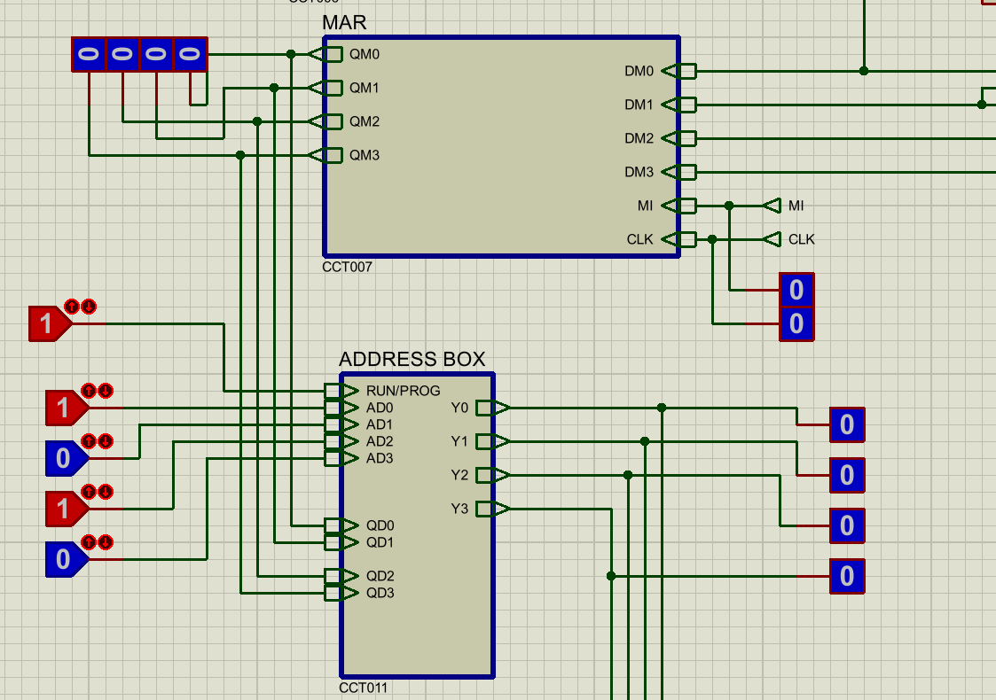
Figure 5 Block diagram of Input unit, MAR, Address Box

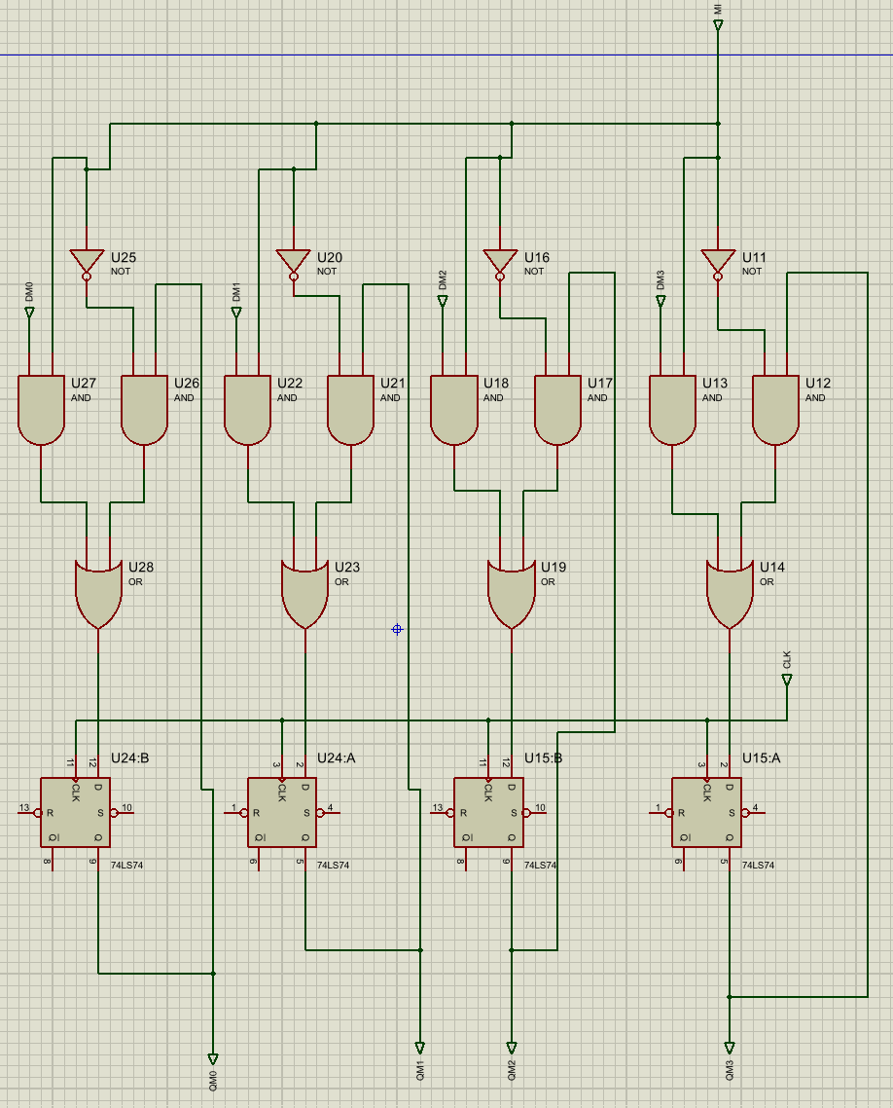
Figure 6 Circuit diagram of Memory Address Register

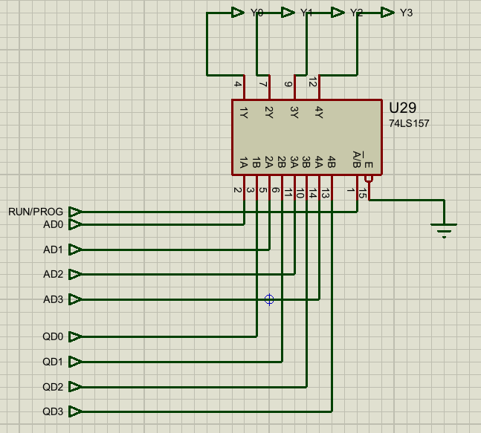
Figure 7 Circuit diagram of Address Box

Phase 2:

1. Accumulator
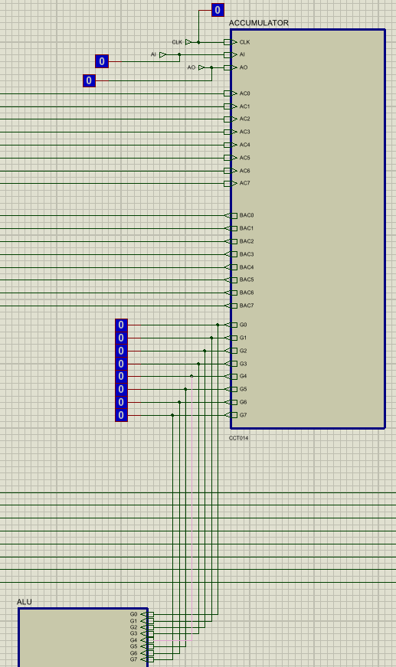
Figure 8 Block Diagram of Accumulator

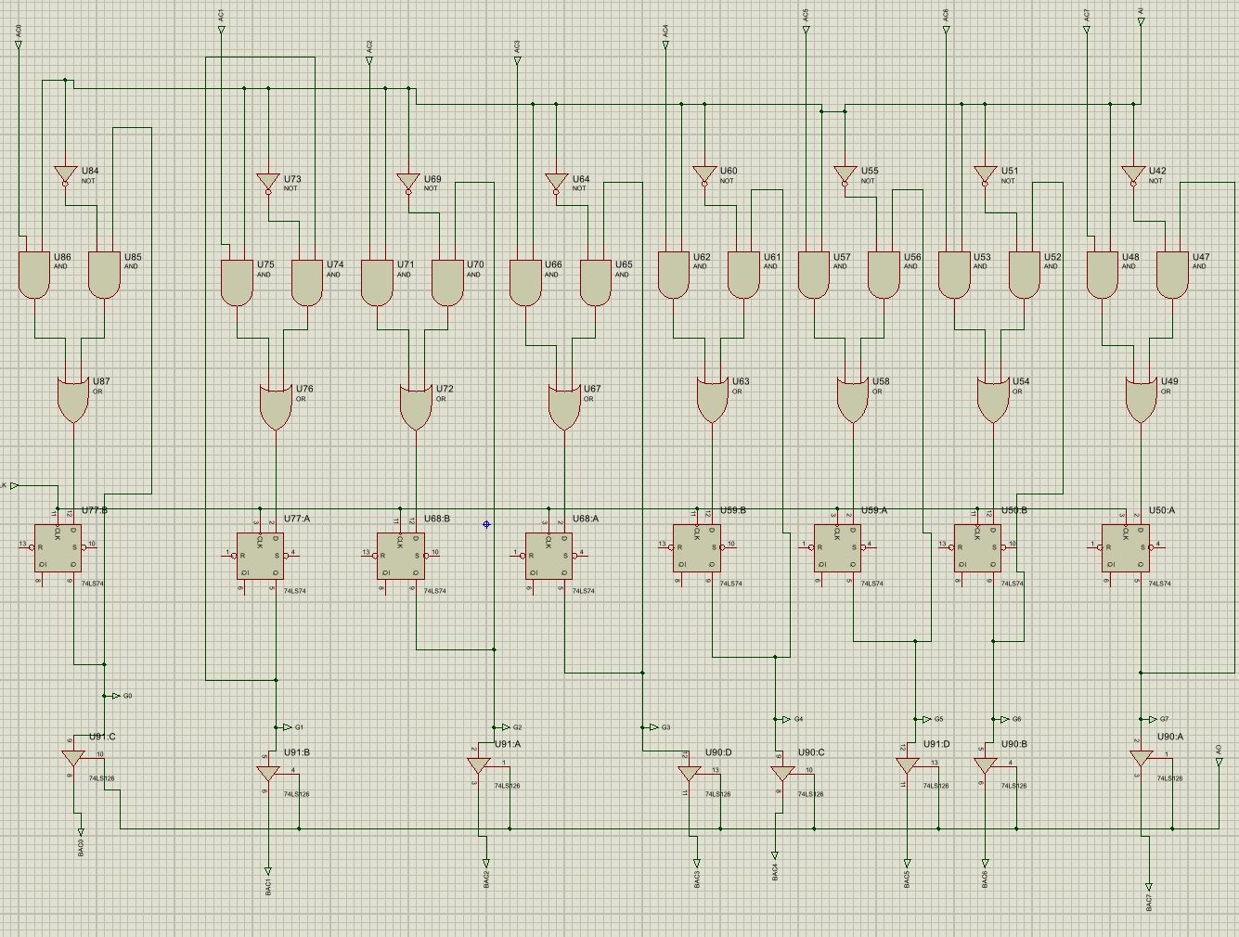
Figure 9 Circuit Diagram of Accumulator
The accumulator is the main working register of the system. It stores intermediate data values and holds the results produced by the arithmetic and logic unit (ALU). The accumulator can load new data from the bus and can also place its stored value back onto the bus when required.
Input and Output Signals
Inputs
- CLK: Clock signal for synchronous operation
- AI (Accumulator Input): Enables loading data into the accumulator
- AO (Accumulator Output): Enables the accumulator to place its value onto the system bus
- AC0–AC7: 8-bit data input lines, typically coming from the ALU or system bus
Outputs
- BAC0–BAC7 / G0–G7: 8-bit accumulator output lines connected to the system bus or ALU

The accumulator is implemented as an 8-bit register using D flip-flops. Each flip-flop stores one bit of the accumulator value. All flip-flops share a common clock so that data is loaded synchronously.
The input to each flip-flop is controlled using combinational logic made up of AND, OR, and NOT gates. This logic decides whether the accumulator should load new data or retain its previously stored value. When the AI signal is active, the data present on the input lines is allowed to pass into the flip-flops and is stored on the active clock edge. When AI is inactive, the accumulator holds its current value.
To control the output, tri-state buffers are used. These buffers connect the accumulator outputs to the system bus only when the AO signal is active. When AO is inactive, the outputs are placed in a high-impedance state, preventing bus contention with other registers.
This design allows the accumulator to independently control data loading and data output, which is essential for correct operation of arithmetic and data-transfer instructions.
Algorithm
The accumulator monitors the AI and AO control signals.
If AI = 1, the accumulator loads new data from the input lines on the clock edge.
If AI = 0, the accumulator retains its previously stored value.
If AO = 1, the stored accumulator value is placed onto the system bus.
If AO = 0, the accumulator output remains disconnected from the bus.
Truth Table
AO | AI | Accumulator Behavior
0 | 0 | No change
0 | 1 | Data loaded from bus/input
1 | 0 | Data output to bus
1 | 1 | Data loaded and output

2. B Register
The B register is used as a temporary storage register for operands required by the Arithmetic and Logic Unit (ALU). It stores an 8-bit value that is used directly by the ALU during arithmetic and logical operations.
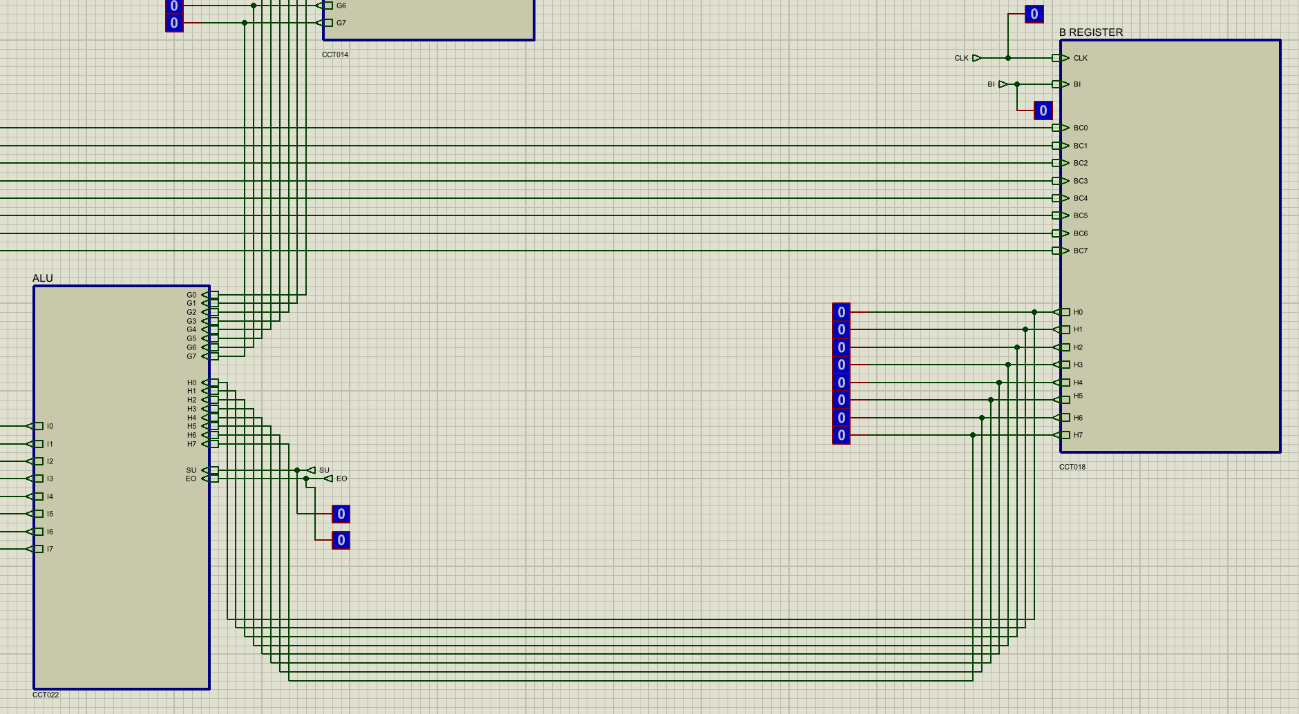
Figure 10 Block Diagram of B register
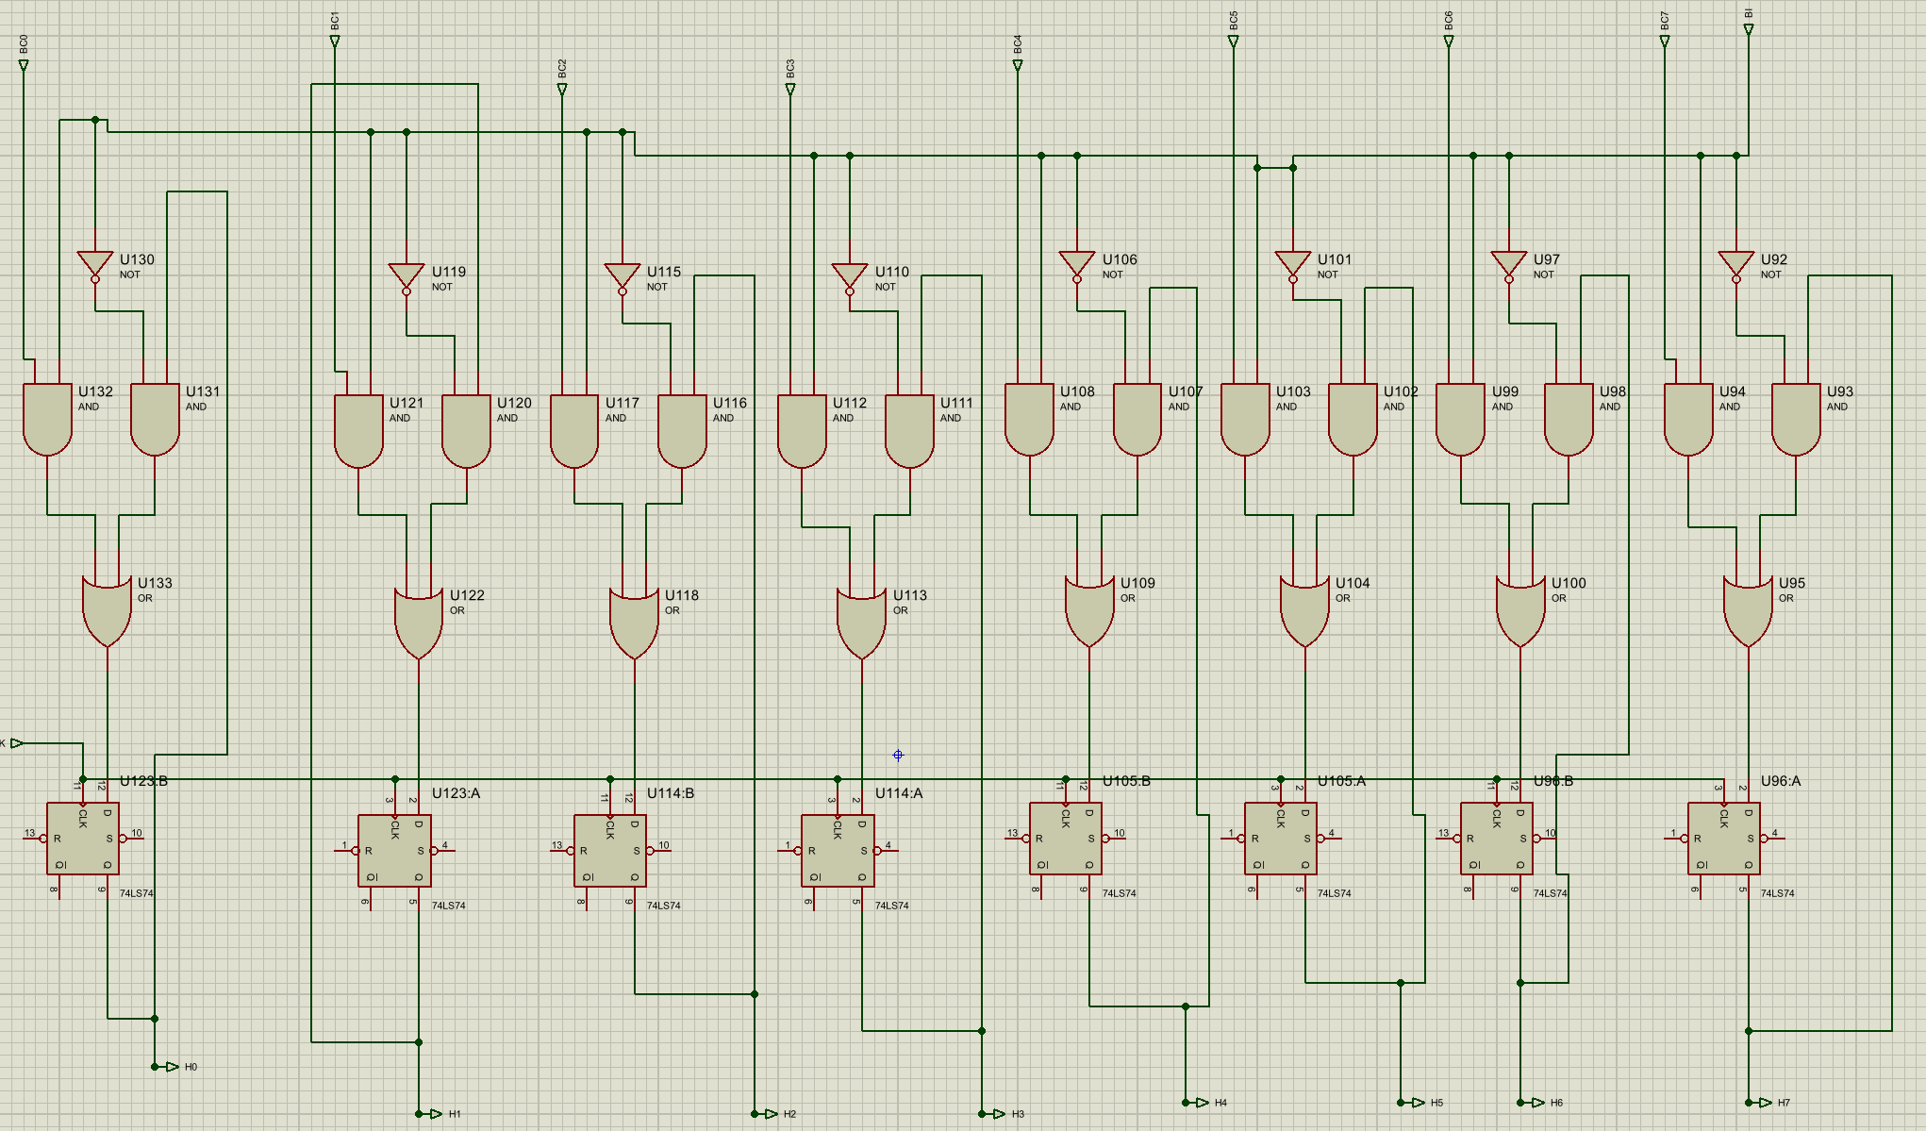
Figure 11 Circuit Diagram of B Register
Input and Output Signals
Inputs
- CLK: Clock signal for synchronous operation
- BI (B Register Input): Enables loading data into the B register
- BI0–BI7: 8-bit data inputs
Outputs
- BO0–BO7 / H0–H7: 8-bit outputs connected directly to the ALU inputs

The B register is implemented as an 8-bit register using D flip-flops. Each flip-flop stores one bit of the register value, and all flip-flops operate using a common clock signal.
The input logic of the B register is similar to that of the accumulator. AND, OR, and NOT gates are used to control whether new data is loaded or the previously stored value is retained. When the BI control signal is active, the data present on the input lines is loaded into the register on the active clock edge. When BI is inactive, the B register holds its current value.
Unlike the accumulator, the B register does not include any output control or tri-state buffering. Its outputs are always active and are directly connected to the ALU. This allows the ALU to continuously access the value stored in the B register whenever an operation is performed.
Algorithm
The B register monitors the BI control signal.
If BI = 1, the register loads new data from the input lines on the clock edge.
If BI = 0, the register retains its previously stored value.
The stored value is continuously available at the register outputs and fed directly to the ALU.
Truth Table
BI | B Register Operation
0 | Holds current value
1 | Loads new data

3. Output Register
Input and Output Signals
Inputs
- OI0–OI7: 8-bit data inputs from the system bus
- CLK: Clock signal for synchronous operation
- OI (Output Register Input): Load enable signal for the output register
Outputs
- OO0–OO7: 8-bit outputs connected to binary output indicators

Block Diagram
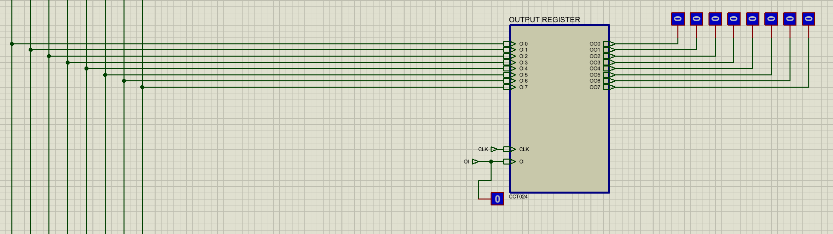Figure 12 Block diagram of output register
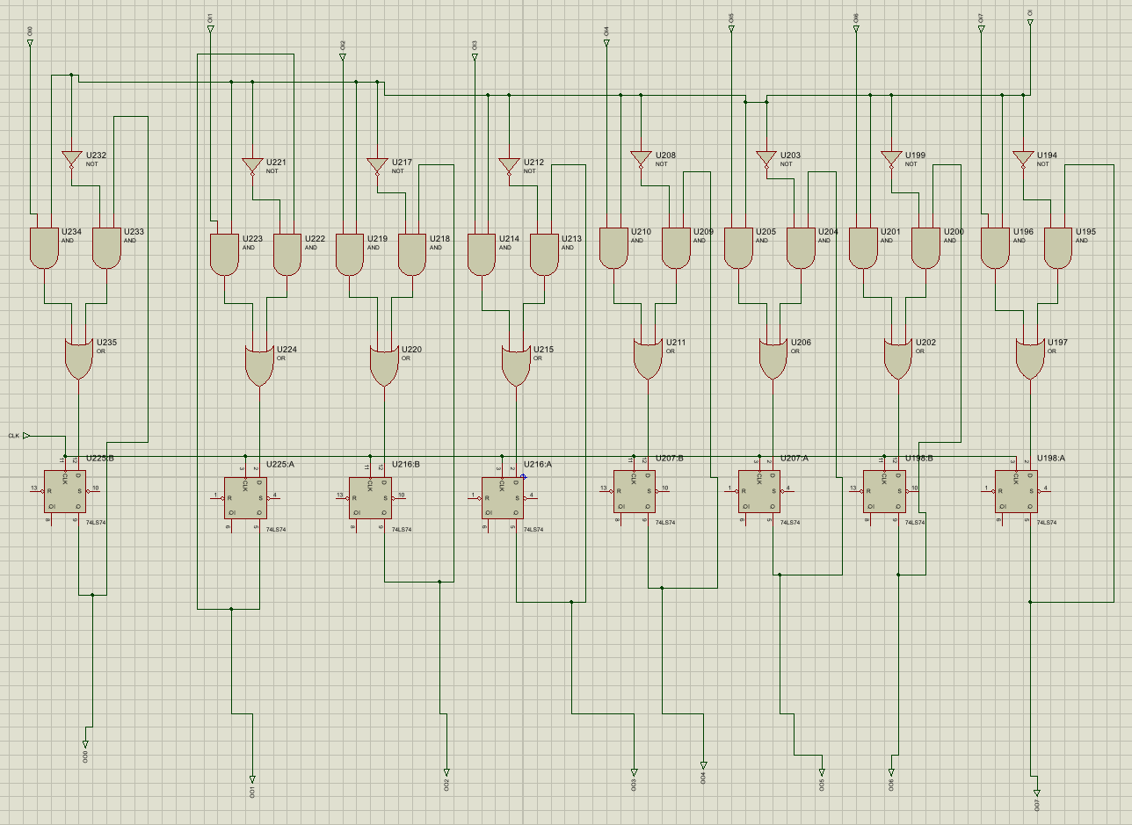
Figure 13 Circuit diagram of output register
The output register is implemented as an 8-bit register using D flip-flops. Each flip-flop stores one bit of the output value, and all flip-flops share a common clock signal.
The input logic of the output register is similar to that of other registers in the system. AND, OR, and NOT gates are used to control whether new data is loaded or the previous value is retained. When the OI control signal is active, the data present on the input lines is loaded into the register on the active clock edge. When OI is inactive, the register holds its previously stored value.
Unlike the accumulator, the output register does not need to place data back onto the system bus. Therefore, no output enable or tri-state buffer is required. As soon as data is stored in the output register, it is continuously available at the outputs and is directly connected to the output indicators.
This design ensures that the final output remains stable and visible even while the rest of the processor continues operating.
Algorithm
The output register monitors the OI control signal.
If OI = 1, the register loads new data from the system bus on the clock edge.
If OI = 0, the register retains its previously stored value.
The stored value is continuously presented at the output lines for display.

Truth Table
OI | Output Register Operation
0 | Holds current value
1 | Loads new data

4. Random Access Memory
In this project, a 16 × 8 RAM is implemented, meaning it contains 16 addressable memory locations, each capable of storing 8 bits of data.
In the simulation, the RAM is implemented in Proteus using standard RAM ICs. However, the internal working of these ICs follows the same fundamental memory principles taught in theory. Therefore, theoretical diagrams, state tables, and logic derivations are included to explain the internal operation of the RAM ICs used in the simulation.
RAM Size and Address Calculation
The number of memory locations in a RAM depends on the number of address lines and is given by:
Number of memory locations = 2ⁿ
where n is the number of address lines.
In the implemented RAM:
- Number of address lines = 4 (Y0 to Y3)
- Number of data lines = 8 (DR0 to DR7)
Therefore, the total number of memory locations is:
2⁴ = 16 locations
Hence, the memory size of the implemented RAM is:
16 × 8 RAM
This calculation directly matches the 74LS189-based RAM implementation used in the Proteus simulation.
Block diagram of RAM
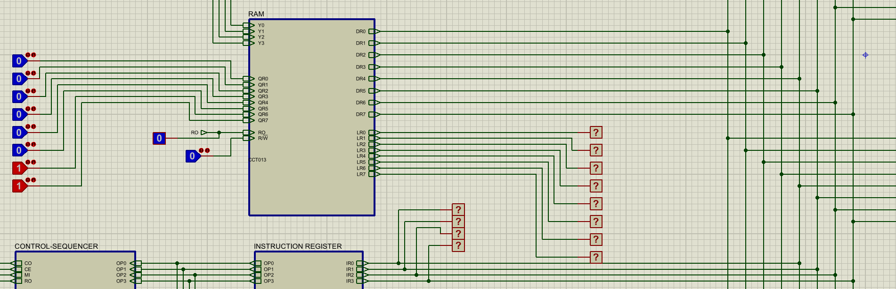
Figure 14 Block diagram of RAM

The RAM block consists of:
- Address inputs (Y0–Y3)
- Data input lines (QR0–QR7)
- Data output lines (DR0–DR7)
- Read/Write control
- Output enable control (RO)
1-Bit RAM Cell
To understand how data is stored inside the RAM ICs used in the simulation, it is necessary to study the operation of a 1-bit RAM cell.
A 1-bit RAM cell requires:
- A storage element
- Write control
- Read control
In theory, this storage element is implemented using an S–R latch. An equivalent implementation using a D flip-flop is used instead because of reliability issues of S-R latch.
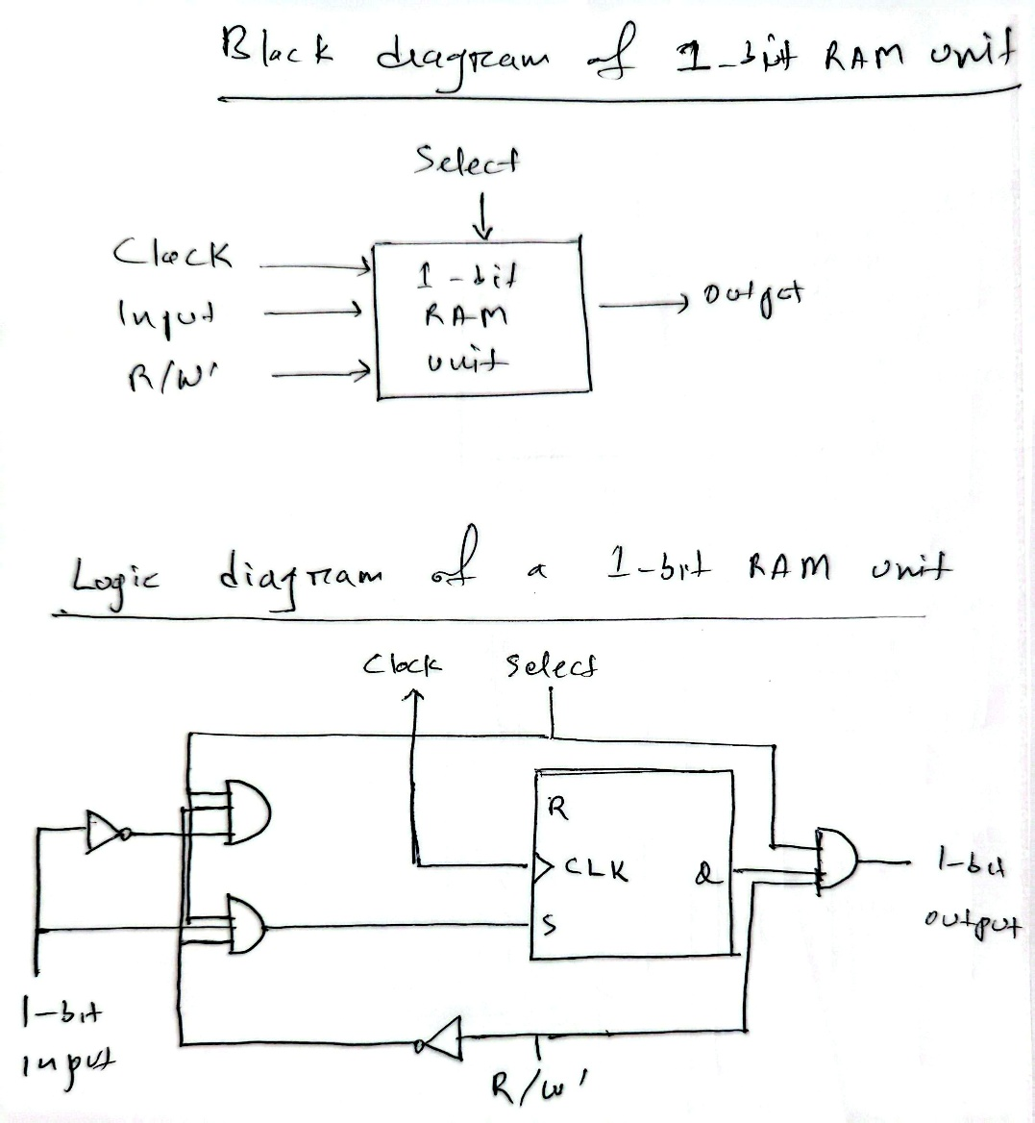

To convert S–R latch behavior into a D flip-flop implementation, the following state table is derived.
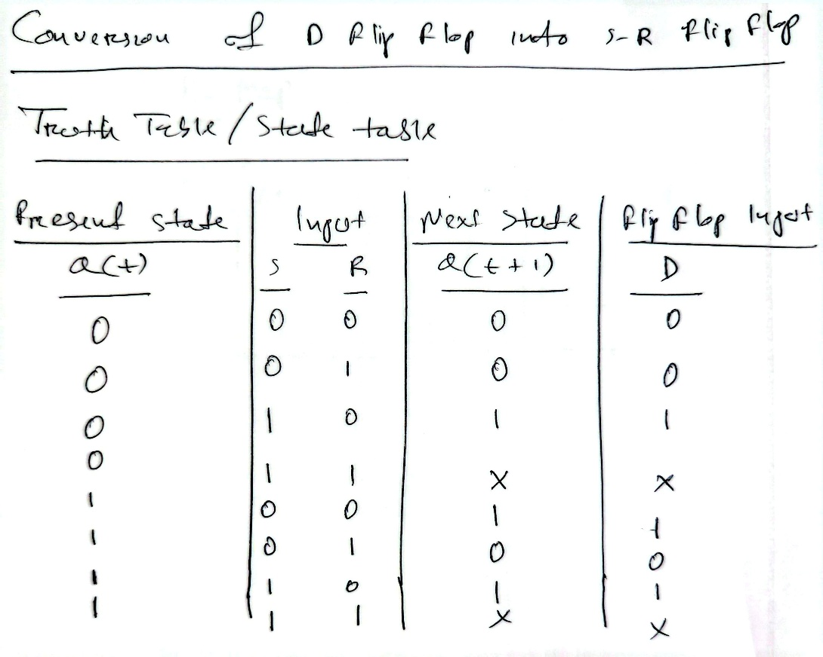
The invalid cases (S = 1, R = 1) are treated as don’t-care conditions, since this state is not allowed in practical memory operation.
This state table forms the theoretical foundation for the storage behavior implemented inside the RAM ICs.
Karnaugh Map Simplification
Using the state table above, a Karnaugh map is constructed by treating invalid states as don’t-care terms.
From the Karnaugh map, the simplified Boolean equation for the D input is obtained:
D=S+QR’
This equation ensures:
- New data is written when write control is active
- Stored data is retained when write control is inactive
Although this logic is not explicitly built gate-by-gate in the simulation, the same behavior is internally implemented within the RAM ICs used.
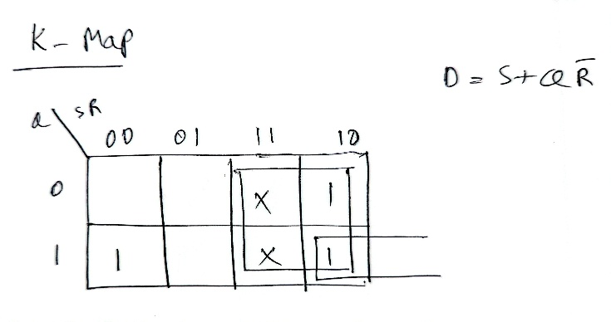
Logic Diagram
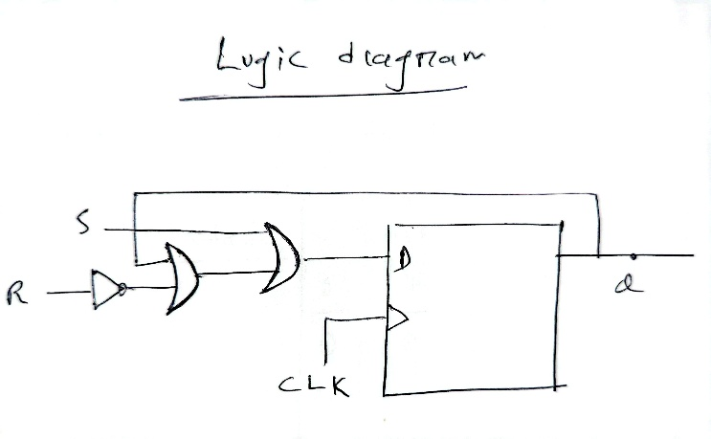
The logic diagram consists of:
- One NOT gate to generate R’
- One AND gate for QR’
- One OR gate combining S and QR’
This logic diagram explains how each memory bit inside the RAM IC decides whether to update or retain its stored value.

Construction of Larger RAM Blocks
4 × 4 RAM
A 4 × 4 RAM is formed by arranging:
- 16 individual 1-bit RAM cells
- 2 address lines
- A 2-to-4 decoder for row selection
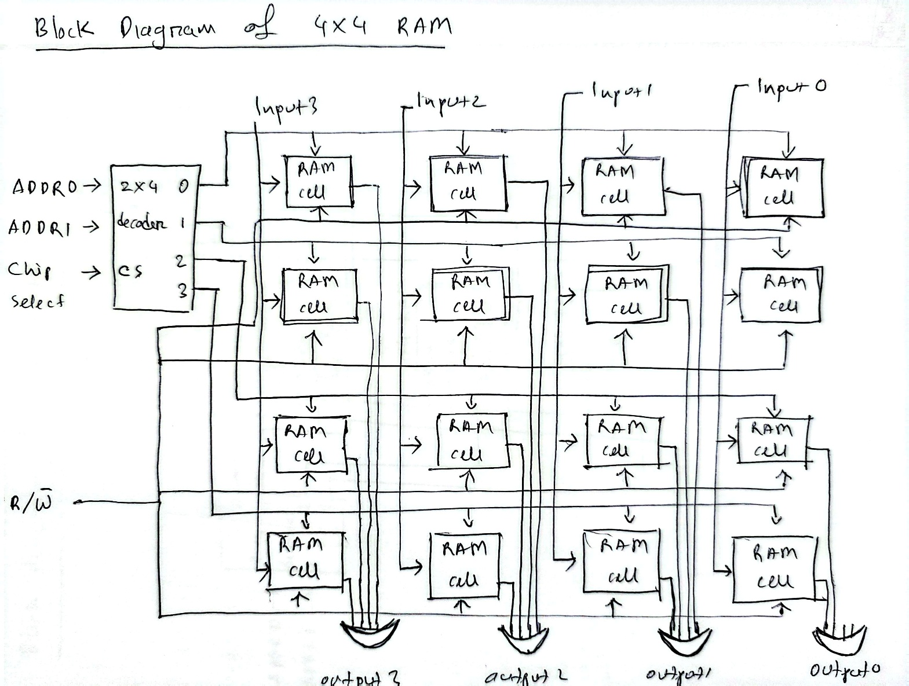
This diagram explains the internal structure of the memory blocks that are conceptually present inside each 74LS189 RAM IC.

16 × 8 RAM
A 16 × 8 RAM is constructed by combining multiple 4 × 4 RAM blocks. Address decoding selects the required memory block, while data lines are grouped to form an 8-bit word.
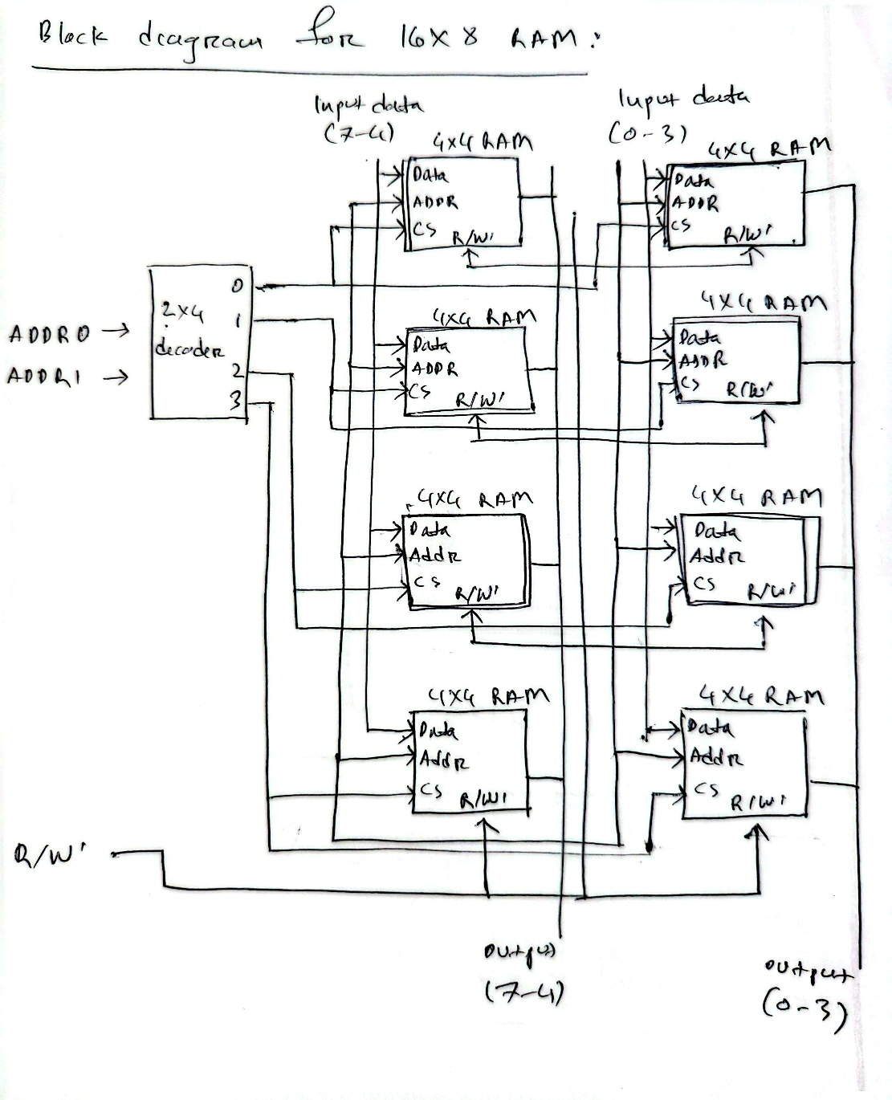
This directly corresponds to the simulation, where:
- Two 74LS189 (16 × 4) RAM ICs are connected in parallel
- Each IC stores 4 bits, together forming an 8-bit word

Simulation Implementation (Proteus)
In the Proteus simulation, the RAM is implemented using:
- Two 74LS189 (16 × 4) RAM ICs
- Shared address lines (Y0–Y3)
- Common Read/Write control
- Output enable control using tri-state buffers
Since the outputs of the 74LS189 are inverted, NOT gates are used to restore correct logic levels before data is placed on the bus.
This implementation faithfully follows the theoretical concepts.
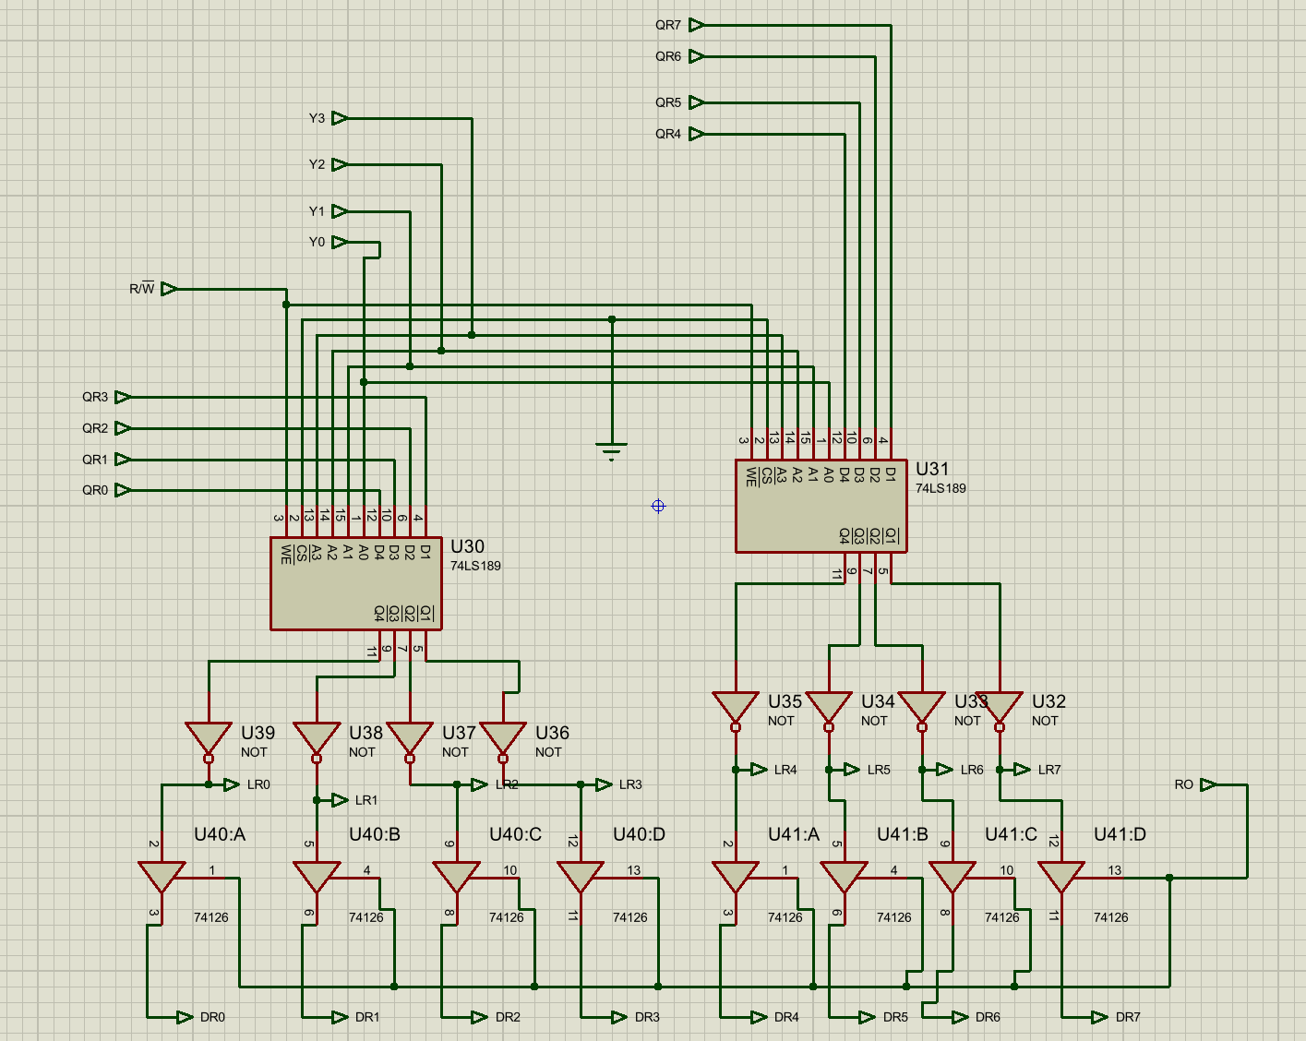Figure 15 Circuit diagram of RAM

Truth Table for RAM Control Signals
Read/Write Control
R/W | Operation
0 | Write enabled
1 | Read operation

Output Enable (RO)
RO | RAM Output
0 | High impedance (bus not driven)
1 | Data driven onto bus

Phase 3:

1. Arithmetic and Logic Unit (ALU):
The Arithmetic and Logic Unit (ALU) is responsible for performing arithmetic operations on 8-bit binary data within the processor. In this project, the ALU supports addition and subtraction operations. The ALU is implemented in Proteus using standard digital ICs, while its operation follows the theoretical principles.
Block diagram
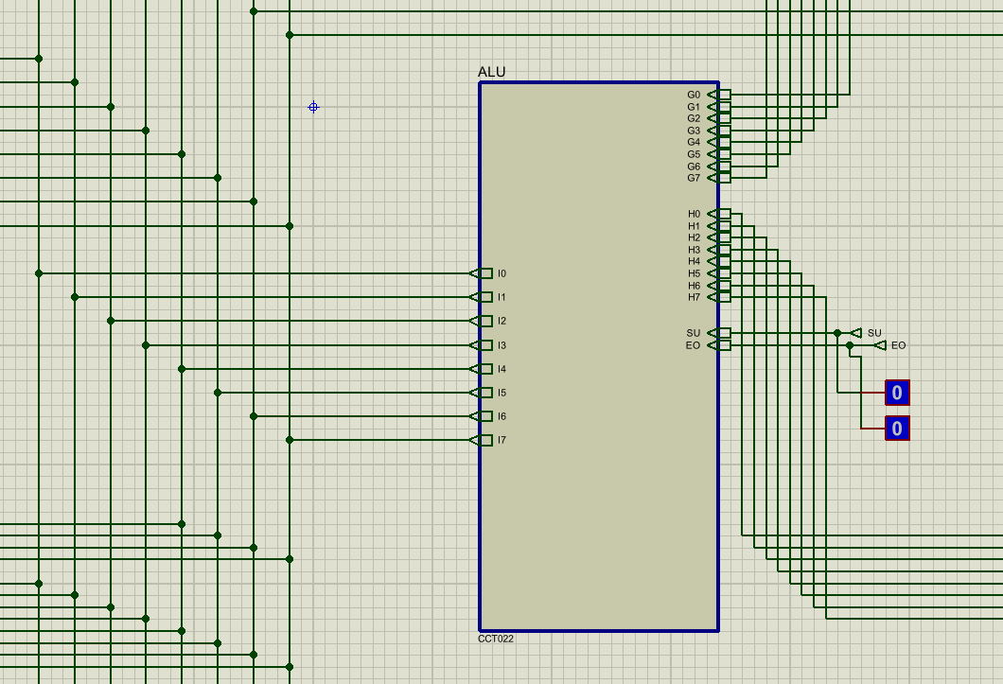
Figure 16 Block diagram of ALU
The block diagram shows two 8-bit inputs to the ALU:
- Input A (from the Accumulator)
- Input B (from the B Register)
The control signal SU determines whether the ALU performs addition or subtraction.
ALU Operation Principle
The ALU performs arithmetic operations using the following approach:
- Addition is performed by directly adding the contents of Register A and Register B.
- Subtraction is performed using the 2’s complement method:
  - The bits of Register B are inverted (1’s complement).
  - A carry-in of 1 is added to complete the 2’s complement.
This method allows both addition and subtraction to be implemented using the same binary adder hardware.
Role of the XOR Gates

Input 1 (SU) | Input 2 (B) | XOR Output
0 | 0 | 0
0 | 1 | 1
1 | 0 | 1
1 | 1 | 0
From the XOR truth table:
- If SU = 0, the XOR output equals the original B input.
- If SU = 1, the XOR output is the complement of the B input.
This behavior is used to control the ALU mode:
SU | ALU Mode
0 | ADD
1 | SUB

Thus, when subtraction is selected, the XOR gates automatically generate the 1’s complement of Register B, which is required for 2’s complement subtraction.

Binary Addition Using 4-bit Adders
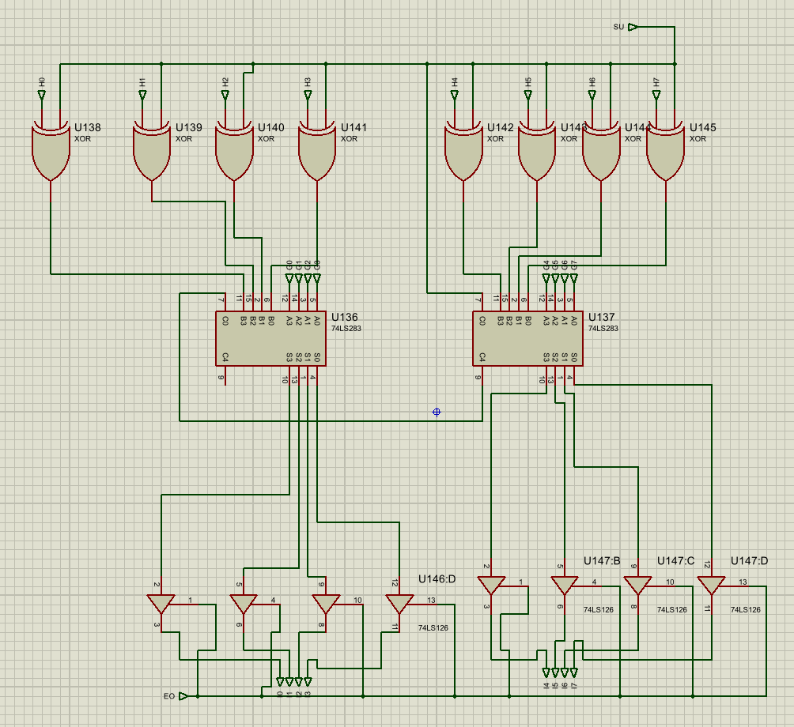
Figure 17 Circuit diagram of ALU
The ALU uses two 4-bit binary adders (74LS283) to implement an 8-bit arithmetic unit:
- The lower 4 bits are processed by the first adder.
- The carry-out from the first adder is connected to the carry-in of the second adder.
- The second adder processes the upper 4 bits.
The control signal SU is also connected to the carry-in of the first adder. When SU = 1, this adds the required +1 to complete the 2’s complement subtraction. The EO signal controls the tri-state buffers at the ALU output. When EO = 1, the ALU drives the system bus; when EO = 0, the ALU output remains in high-impedance state.

Phase 4:

Instruction Register
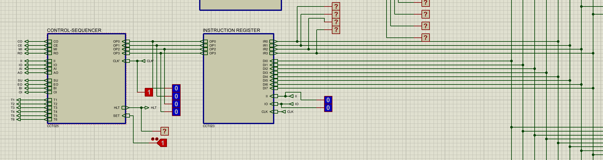
Figure 18 Block diagram of instruction register
This diagram shows the Instruction Register receiving an 8-bit instruction from the system bus and separating it into two functional parts:
- Upper nibble (opcode)
- Lower nibble (operand / immediate data)
The upper nibble is always routed to the Control Sequencer, while the lower nibble can optionally be placed onto the system bus depending on the control signal IO.
Inputs and Outputs
Inputs:
- II – Instruction Input (load enable)
- IO – Instruction Output (lower nibble enable)
- CLK – Clock signal
- RESET – Clears the Instruction Register
- DI0–DI7 – Data from system bus
Outputs:
- IR7–IR4 – Upper nibble sent to Control Sequencer
- IR3–IR0 – Lower nibble sent to bus (through tri-state buffers)

Internal Operation
Each bit of the Instruction Register is implemented using:
- AND gates
- OR gates
- NOT gates
- D flip-flops (74LS74)
The logic follows the same gated-input register principle used in earlier registers, with two key control signals:
- II (Instruction In): Controls loading data from the bus into the register
- IO (Instruction Out): Controls whether the lower nibble drives the bus
The upper nibble is permanently connected to the Control Sequencer, meaning it does not require an output enable signal.
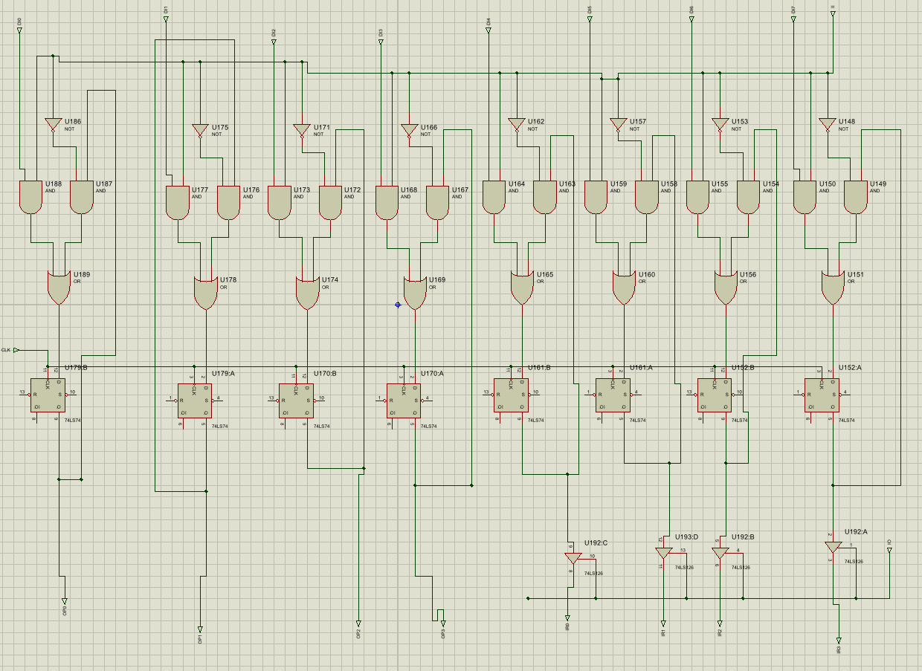
Figure 19 Circuit diagram of Instruction Register

Algorithm of Operation
When II = 1, the 8-bit instruction present on the bus is loaded into the Instruction Register on the active clock edge.
When II = 0, the register retains its previously stored instruction.
The upper nibble (IR7–IR4) is always available to the Control Sequencer.
When IO = 1, the lower nibble (IR3–IR0) is driven onto the system bus.
When IO = 0, the lower nibble remains in high-impedance state and does not affect the bus.
Truth Table
II | IO | Register Mode | Upper Nibble (IR7–IR4) | Lower Nibble (IR3–IR0)
0 | 0 | No change | Sent to Control Unit | Not sent to bus
0 | 1 | No change | Sent to Control Unit | Data stored is sent to bus
1 | 0 | Data loaded from bus | Sent to Control Unit | Not sent to bus
1 | 1 | Data loaded from bus | Sent to Control Unit | Data stored is sent to bus

Controller Sequencer
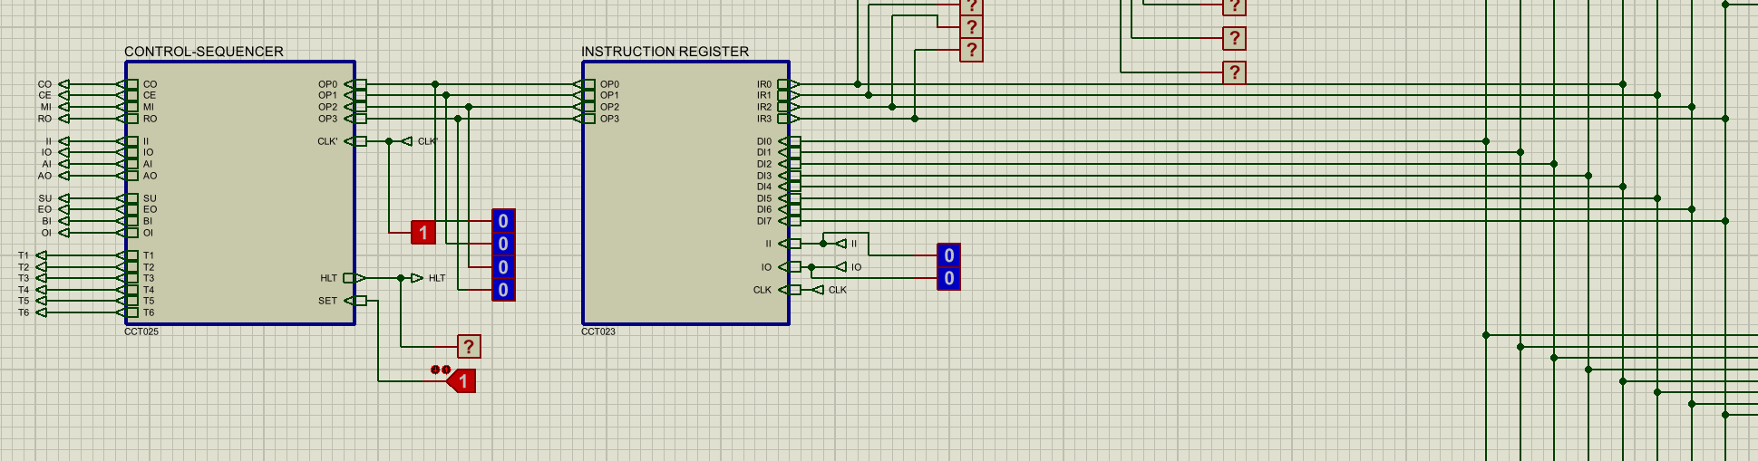
Figure 20 Block diagram of controller sequencer
The Controller Sequencer generates the control signals for the entire CPU by combining:
- Time states (T1–T6) generated from the clock
- Instruction decode from opcode bits (OP0-OP3)
- Combinational control logic to assert the correct control signals at the correct time state
This matches the behaviour implemented in the Proteus circuit, where the control signals are produced through AND/OR logic using decoded instruction lines and decoded time-state lines.
Truth Table
Control Bit | Instruction | Time State at which it is activated | Boolean Expression
CO | ALL | T1 | T1
MI | LDA or ADD or SUB | T3 | T3(LDA+ADD+SUB)+T1
MI | ALL | T1 | T3(LDA+ADD+SUB)+T1
CE | ALL | T2 | T2
RO | ALL | T2 | T2+T4(LDA+ADD+SUB)
RO | LDA or ADD or SUB | T4 | T2+T4(LDA+ADD+SUB)
II | ALL | T2 | T2
IO | LDA or ADD or SUB | T3 | T3(LDA+ADD+SUB)
AI | LDA | T4 | T4(LDA)+T5(ADD+SUB)
AI | ADD or SUB | T5 | T4(LDA)+T5(ADD+SUB)
BI | ADD or SUB | T4 | T4(ADD+SUB)
EO | ADD or SUB | T5 | T5(ADD+SUB)
SU | SUB | T5 | T5(SUB)
AO | OUT | T3 | T3(OUT)
OI | OUT | T3 | T3(OUT)
HLT | HLT | X | HLT

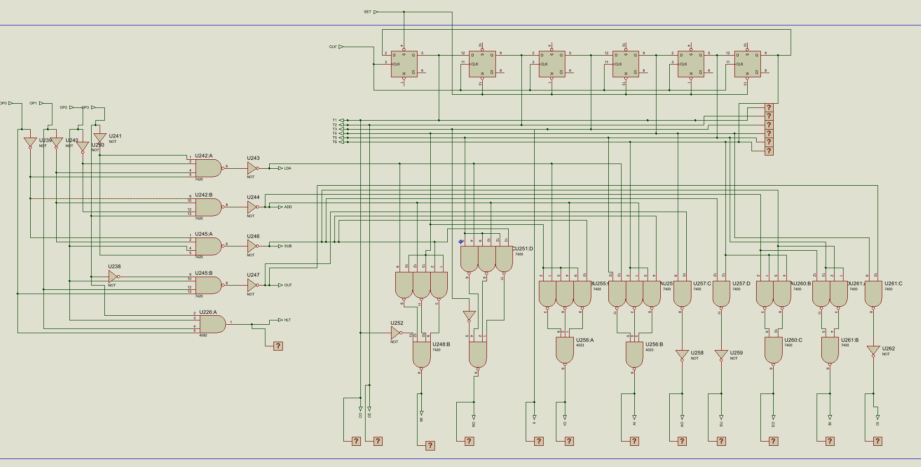
Figure 21 Circuit diagram of controller sequencer

